MEDIA RELEASE
15 October 2014

saarf amps® jun 14

On behalf of the media, marketing and advertising industries, the South African Audience Research Foundation (SAARF) produces the bi-annual All Media and Products Survey (AMPS), providing data on media consumption, demographics, and products, brands and services.
This latest release – SAARF AMPS Jun 14 (2014A) – is characterised by relative stability over the previous survey, with few statistically significant audience level changes coming through.

AMPS JUN 14 QUICK FACTS |  | TOTAL PRINT  63.2% |  | TOTAL NEWSPAPERS  46.3% |  | TOTAL  MAGAZINES  46.9% |  | TOTAL TV  91.8% (p7d)
 |  | TOTAL RADIO  92.4% (p7d) |  | OUT OF HOME  1st: street poles 63.2%  2nd: Minibus taxis 60.7%  3rd: Billboards 60.1% |  | INTERNET USAGE  32.4% (p7d) |  | CINEMA  3.6% (up to 4 weeks)

technical

DATA TRENDING
AMPS Jun 13 (July 2012-June 2013) marked the start of a new trend line for media, following the inclusion of new population estimates modelled on data from Statistics SA’s Census 2011.
The latest release – AMPS Jun 14 – is the third release after this update, and can therefore be trended against the two previous surveys: AMPS Jun 13 and AMPS Dec 13.
FIELDWORK PERIOD
- The large urban component of AMPS Jun 14 covers July 2013 to June 2014.
- The small-urban/rural component covers January to June 2013, and January to June 2014. Ordinarily, this release of AMPS would carry a small-urban/rural component running from July 2013 to June 2014; for AMPS Dec 13, however, the SAARF Board decided not to interview the small-urban/rural sample in the July to December 2013 period.
- The total sample size was 25 510 adults aged 15 years and older.
UNIVERSE SIZE
AMPS Jun 14 uses population figures updated to the 2014 IHS estimates. The AMPS universe of adults aged 15+ is now 1.2% larger, rising from 37.214-million to 37.665-million. The household population rose from 14.978-million in the previous AMPS release to 15.236-million currently, an increase of 1.7% or 258 000 households.
RELEASES COVERED BY THIS REPORT
Comparisons of results and trends are from three AMPS releases:
- The current release, AMPS Jun 14;
- The previous release, AMPS Dec 13 (large urban component covering January to December 2013; small-urban/rural component covering July 2012 to June 2013); and
- AMPS Jun 13 (July 2012 to June 2013).
STATISTICAL SIGNIFICANCE
Only statistically significant changes are reported in this document. Any up or down arrows used represent statistically significant changes.

demographics

LIVING STANDARDS MEASURE (LSMs)
QUICK FACTS |  | LSM 1  The only statistically significant change:  1.4% to 1.8% |  | LSM 1-3  23% |  | LSM 5-7  52.1% |  | LSM 8-10  24.8%

Two of the variables used to create SAARF’s Living Standards Measure have been changed; this is done so that the LSM better reflects the constantly changing nature of South Africans’ standard of living.
Having a hi-fi or music centre has been added, while the ‘two cellphones per household’ variable has fallen away.
The new LSMs show some regression over the previous survey. The proportion of LSM 1 increased; 1.8% of the SA population is now in LSM 1, compared to 1.4% in the previous survey. LSM 4 also showed an upward trend as people previously in higher LSMs experienced a decline in their standard of living.
In the middle to upper LSMs, LSM 5-6 and LSM 8-9 show trends of decline, while there were signs of growth for LSM 7 and 10.
The backsliding of South Africa’s standard of living is possibly linked to the damage done to the economy by the protracted strikes in the platinum mining industry, which had a detrimental knock-on effect in a number of sectors.

WORK STATUS
QUICK FACTS |  | Unemployed: 31.1% |  | Working full-time: 27.4% |  | Working part-time: 8.2%

There were no statistically significant changes to work status. While the proportion of adults in full-time employment has trended up slightly (27.4%), the proportion of unemployed adults has also risen (31.1%).
The incidence of part-time work has dropped off slightly (8.2%), as has the proportion of adults claiming to be students (14.8%). Just over 11% of adults are retired, while 7.3% are housewives.

AVERAGE HOUSEHOLD INCOME
QUICK FACTS |  | Average R9 997 per month per household. |  | Zero to R4 999 per month:  42% of households  (was 43.3%) |  | R5 000 plus:  58% of households  (was 56.7%)

Average household income rose from R9 777 to just shy of R10 000 per month, at R9 997. This is an increase of only 2.3% over the previous survey, which is well below the inflation rate of 6%+.
There was a declining and therefore positive trend for the three lowest income brackets. Only 2.6% of households now have to survive on less than R800 a month, a smaller proportion than the previous survey. The R800-R1 399 bracket now represents 8.3% of households, significantly down from 9.0%, while 9.6% of households fit into the R1 400-R2 499 bracket, a statistically significant drop from 11.0% previously.
All other income brackets, with the exception of the R8 000-R10 999 bracket which lost ground slightly, showed signs of growing in proportion.
HOUSEHOLD INCOME GROUPS | AMPS  Dec 13 | AMPS  Jun 14
Up to R799 | 2.8% | 2.6%
R800-R1 399 | 9.0% | 8.3%
R1 400-R2 499 | 11.0% | 9.6%
R2 500-R4 999 | 20.5% | 21.5%
R5 000-R7 999 | 16.7% | 17.5%
R8 000-R10 999 | 11.3% | 11.2%
R11 000-R19 999 | 13.5% | 13.6%
R20 000+ | 15.2% | 15.7%
Statistically significant decline

EDUCATION
QUICK FACTS |  | 99.0% have basic literacy, 93.4% have functional literacy. |  | 46.6% have matric or higher |  | 3.7% have a university degree

While education levels remained stable, there were nonetheless positive trends for basic literacy and functional literacy (primary school completed). The proportion of adults holding a matric qualification or university degree has, however, trended slightly down.

ACCESS TO SERVICES, AND DURABLES IN THE HOME
Access to electricity (92.9%) remained unchanged, with access to water in the home or on the plot up slightly (82.7%). A lower proportion of homes have flush toilets (67.6%), while hot-water geysers are more prevalent (41.6%) than they were in the previous survey.
In terms of durables in the home, the only statistically significant change was to ownership of microwave ovens, which declined from 63.8% previously to 62.6% in the current survey.
media

print

Print readership remained stable over AMPS Dec 13, despite the medium as a whole losing audience in the North West, the 15-24 age group and LSM 8-10. Print now reaches 63.2% of all adults.
Despite its stability, however, the decline in total readership of newspapers (and specifically of weekly newspapers) has contributed to a downward trend for total print.
Magazine readership has remained steady over the previous survey.
Access platforms for this medium remained stable, with online reading showing a slight uptick (7.3%), and cellphone reading remaining entirely unchanged at 4.4%.
QUICK FACTS |  |  |  | TOTAL PRINT:  63.2% |  | TOTAL NEWSPAPERS:  46.3% |  | TOTAL DAILIES:  28.7%
 |  | TOTAL WEEKLIES:  30.2% |  | TOTAL MAGAZINES:  46.9% |  | Newspaper repertoire:  1.99 per person |  | Magazine repertoire:  2.90 per person

newspapers

In the previous AMPS release, newspaper readership remained stable. This period, however, brings with it a significant decline in average-issue readership for the sector.
Average-issue readership (AIR) for TOTAL NEWSPAPERS declined from 47.8% in the previous AMPS release to 46.3%, a loss of 354 000 readers. Demographics which contributed most to this loss were metros, the Eastern Cape, Gauteng, Vaal and the Reef, the 15-24 age group, LSM 8-10, and the coloured and white reader bases.
The decline in total readership was driven almost entirely by a decline in WEEKLY NEWSPAPERS. Average-issue readership of weeklies decreased from 31.6% to 30.2%, a loss of 352 000 readers, leaving a total readership of 11.393-million. These losses came through from metro and Gauteng bases, with fewer female readers, and fewer readers in LSM 8-10 and in the 15-24 age bracket.
DAILY NEWSPAPERS held their own with no statistically significant movement: average-issue readership of dailies is 28.7% with 10.812-million readers. These readership figures, however, are trending down on the previous period. Losses occurred in the Free State, Gauteng, and on the Vaal, although not enough to impact on total daily readership.
In terms of repertoire, newspaper readers read an average of 1.30 daily newspapers and 1.65 weekly newspapers, figures which show a slight downward trend. On average, people read 1.99 newspapers in total, down slightly from 2.05 in the previous period.
REGIONALISATION
Since AMPS Jun 13, newspaper readership has been regionalised during analysis. The provincial distribution of titles is agreed upon by each publisher and reviewed before release.
Distribution changes are highlighted in the AMPS Technical Report.

INDIVIDUAL PUBLICATION RESULTS
National newspapers
One national paper lost ground over the previous period; City Press’s readership declined from 5.4% to 4.8%, with a loss of metro readers and LSM 8-10 readers coming through.
Sunday Times lost readers in LSM 8-10.
Vuk’uzenzele lost readers in large urban areas, and in the Eastern Cape.
Gauteng newspapers
Daily Sun showed a significant decline in readership: from 15.2% to 14.2%. Losses came through from a number of demographics: large urban areas, the Free State, Gauteng, Bloemfontein and the Vaal, and males.
Readership of Pretoria News declined from 0.5% to 0.3%.
Sunday World lost readers in large urban areas and in LSM 8-10.
KwaZulu-Natal newspapers
Isolezwe’s Durban-based readership increased over the previous survey.
No newspapers from any other newspaper region showed any statistically significant changes, either in readership or demographic profile.

magazines

Unlike newspapers, magazines maintained an even keel over the previous AMPS release.
Average-issue readership of magazines in total – currently 46.9% – shows a downward trend, although this was not statistically significant. More adults in Mpumalanga have taken to the medium, while there were losses in metros, amongst females, in LSM 8-10 and in the coloured and white demographics.
AVERAGE ISSUE READERSHIP BY FREQUENCY OF PUBLICATION:
- Any weekly magazine: 23.6% readership, down on the previous period’s 25.1%. This sector’s 8.885-million audience now has a lower proportion of large urban readers (and particularly from the Western Cape), females, 15-24 year olds, and LSM 8-10.
- Any fortnightly magazine: Stable at 3.8% readership, 1.434-million readers.
- Any monthly magazine: Stable at 36.5% readership, 13.733-million readers, but with a decline in large urban areas and LSM 8-10, and gains in Mpumalanga.
- Any alternate-monthly magazine: Stable at 4.8% readership, 1.814-million. Alternate monthlies saw declines in large urban areas and LSM 8-10.
- Any quarterly magazine: A significant decline in average-issue readership, down from 1.5% in the previous survey to 1.0%, with 394 000 readers. Losses came through from large urban areas and the Western Cape, LSM 8-10, males, and the 15-24 age group.
On average, people read 2.90 magazines each, which is slightly down on the previous period’s 3.06.

CONSUMER MAGAZINES
There were readership and demographic shifts in the following consumer magazine groupings:
Family interest magazines
Only demographic shifts came through in this interest group: Bona grew its 50+ audience, while Huisgenoot lost coloured readers and readers in large urban areas. Drum lost readers in LSM 8-10.
Women’s general magazines
Four of the nine titles in this group showed significant declines over the previous AMPS release.
True Love lost readers in urban areas and in the 15-34 age group, causing a drop in total readership from 6.7% to 6.0%
Readership of Move! dropped from 6.2% to 5.3%, due in large part to declines in readership in Limpopo and the North West, amongst females, in LSM 8-10, and in the 15-24 age group.
Cosmopolitan’s reader base declined from 2.2% of the adult population, to 1.8%. Declines were from large urban areas and Gauteng in particular, and from the female demographic and LSM 8-10.
A decline was seen for Rooi Rose, whose readership dropped from 2.1% to 1.7%; males, coloured readers, those aged 35-49, and LSM 5-7 were some of the main demographics behind this decline.
Glamour lost readers in metro areas.
Fair Lady lost a statistically significant number of white readers.
Business and news magazines
Entrepreneur lost readers in metro areas and in LSM 8-10.
Entertainment and celebrity magazines
DStv magazine gained 628 000 readers over the previous period, pushing its readership up from 15.1% to 16.6%. New readers came from small-urban/rural areas and Gauteng, from the 25-34 age group,
LSM 5-7, and from the black community.
Parenting magazines
Your Pregnancy lost readers in the 25-34 age group.
Travel magazines
Getaway’s metro and LSM 8-10 readership bases declined.

STORE MAGAZINES
In total, readership of store magazines has remained remarkably stable over the past two AMPS releases, although there was a decline in total readership in the Eastern Cape. Readership is currently 19.3%, with readership in thousands varying by just 2 000 over the previous year (AMPS Jun 13).
The following titles showed significant readership shifts over AMPS Dec 13:
Clicks ClubCard grew its readership (own/household copy only) from 3.2% previously, to 3.8%. These gains came from all community sizes, males, LSM 5+, and black readers specifically.
Readership for Ackermans Club is 2.2% (own/household copy only), significantly up on the 1.2% of AMPS Dec 13 and the 0.4% of AMPS Jun 13. Gains came from all community sizes, all provinces except Mpumalanga and Limpopo, all age groups, and from LSM 5+.
- Ellerines Club lost readers in metros and in the Eastern Cape (own/household copy only).

television

(Please note that SAARF TAMS® is the official currency for television.)
As in the previous AMPS release, television viewership remained stable, appearing to have levelled off at the 91.8% mark (past 7 days).
The only significant audience-figure movement in the sector came from the two Pay-TV services, DStv and StarSat (previously TopTV).
DStv’s weekly penetration of 33.4% in the previous survey rose to 35.7% in the latest AMPS. (These figures include terrestrial and satellite viewing.) The increased uptake of DStv amongst black viewers has been a large contributor to this growth. The service’s audience was also boosted in the 15-34 age group, and in LSM 1-7.
StarSat posted a significant decline: from 1.1% previously to 0.8% reach per week. Declines were in large urban areas, and in LSM 8-10.
The only other statistically significant shifts in the medium were demographic in nature (past 7 days):
- SABC 1 gained viewers from LSM 5-7;
- SABC 2 gained viewers in the Eastern Cape;
- SABC 3 gained viewers in LSM 8-10 and in Mpumalanga, but lost viewers in KwaZulu-Natal; and
- Community TV lost viewers in Pretoria.
In terms of how viewers access TV content, the overwhelming majority prefer the traditional TV set. (Ownership of a TV set trended up from 88.0% previously to 88.3% currently.) Only 0.7% watch on a cellphone and 1.0% watch online; the use of both these non-traditional viewing devices is also steadily trending down.

radio

(Please note that SAARF RAMS® is the official currency for radio.)
No significant listenership changes were seen either for radio in total, for total commercial/PBS, total community radio, or for any individual radio station.
- Total radio reaches 92.4% of all adults each week.
- Total commercial/PBS radio (all non-community stations): 89.5% reach per week.
- Total community radio: 24.9% reach per week.
As with television, most radio listeners still use traditional devices, but unlike TV, a significant proportion of radio listeners also turn to their cellphones to listen. Cellphone listening’s incidence of 32.6% seen in the previous AMPS release has risen significantly, with 37.1% of adults now listening on their cells as well as on traditional radio sets.
Conversely, online listening and listening via the DStv audio channels has tapered off: from 5.4% to 4.5% for online listening, and from 0.5% to 0.3% for listening on DStv audio.
out of home

(All formats mentioned are those which carry advertising.)
In January 2013, extensive out of home (OOH) methodology changes were introduced in the out of home sector. Previously, each out of home format was prompted separately and the respondent was asked when last he or she saw it. Now, eight of the formats are shown on one screen, and the respondent is asked which types were seen in the past four weeks and in the past seven days.
As a result of this methodology change, AMPS Jun 14 cannot be trended over previous AMPS releases; while the latest 12-month database carried only the new OOH questions, the previous database (AMPS Dec 13) includes interviews from the July to December 2012 small-urban/rural sample, which did not use the new OOH questions.
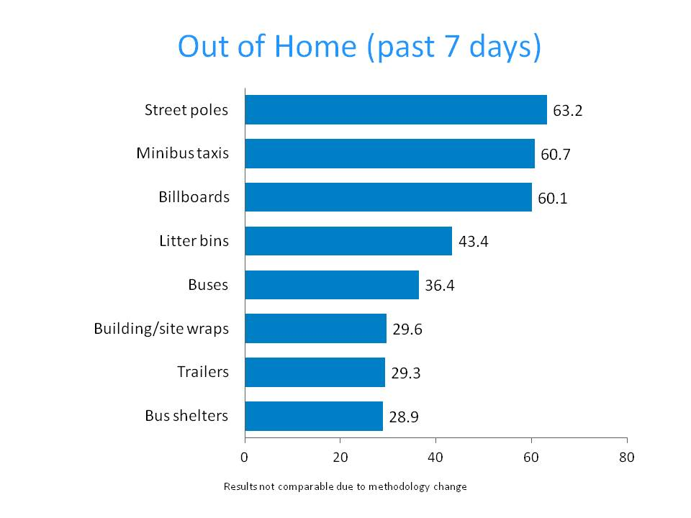

digital

Under the guidance of industry experts, extensive changes were made to the digital and cellphone sections of AMPS. Implemented in AMPS Jul-Dec 2013, these changes saw the two sections being combined and streamlined. Wherever possible, questions were matched for minimum disruption of the data, but not all questions are comparable and data cannot, therefore, be trended.
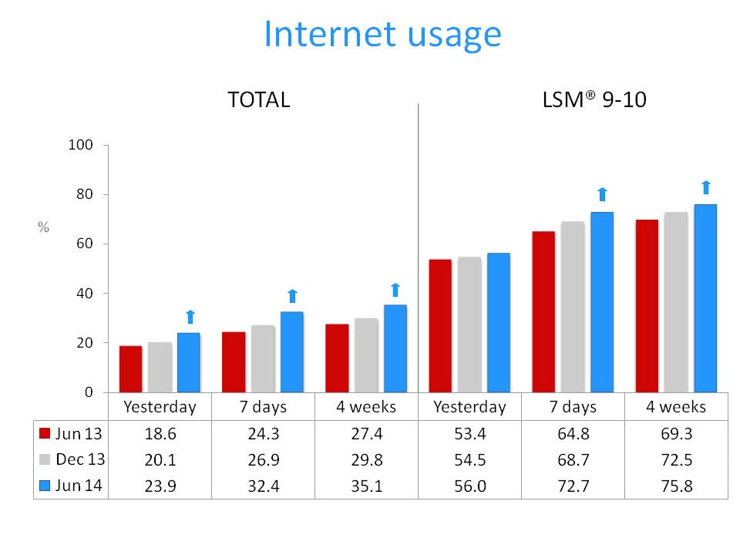
One of the questions that has remained the same and is, therefore, comparable, is the question covering internet usage.
As it does each survey, internet usage has climbed. There were statistically significant gains across all time filters. This growth has been universal: across all community sizes, in all provinces with the notable exception of Limpopo, as well as across all age groups and LSM groups.

cellphones

Following the major revamp of this section of AMPS, implemented from AMPS Jul-Dec 2013 (see digital section above), additional information on cellphones will be released in the 6-month database due to be released in November 2014.
(Please note that all internet-related cellphone activities are now part of the digital/internet section.)
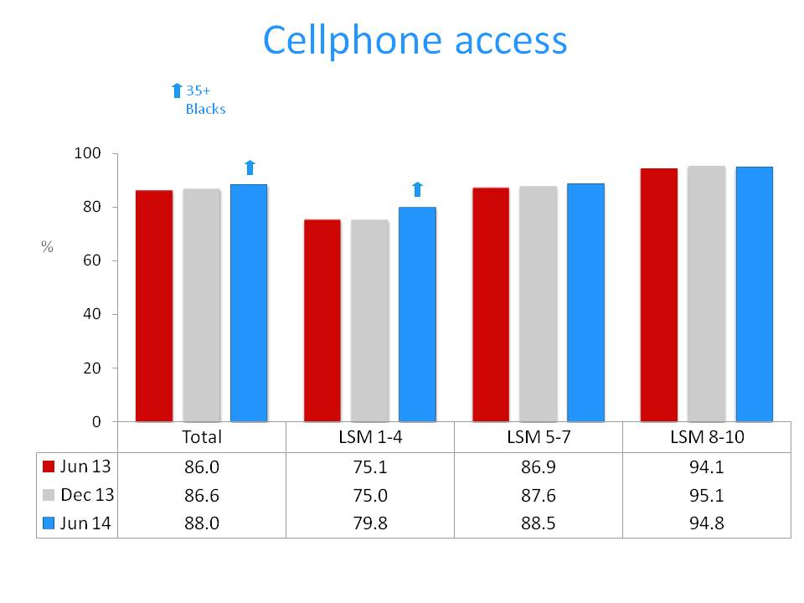
cinema

No statistically significant changes were seen in cinema attendance, across any time filter.
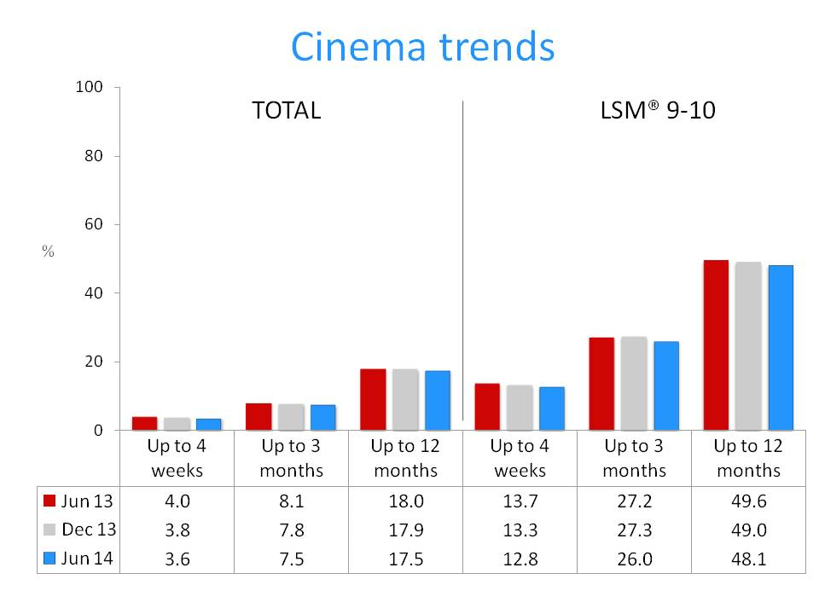
Ends

Note to the editor:
The South African Audience Research Foundation (SAARF) is the provider of research data to the advertising, marketing and media industries. Its main objective is to direct and publish media and product/brand research for the benefit of its stakeholders, thereby providing data for target marketing and a common currency for the buying and selling of media space and time. The information is also used by media owners for strategic programme and editorial planning.
SAARF conducts a number of major media and product/brand surveys. The All Media and Products Survey (AMPS®), includes extensive information on media as well as products, services, brands, attitudes, interests and activities and is South Africa's only free source of data on nearly 120 product categories and over 1 500 brands. Other important surveys are the Radio Audience Measurement Survey (RAMS®); the Television Audience Measurement Survey (TAMS®) and the SAARF Out of Home Media Survey (OHMS). SAARF also provides comprehensive information on target groups, and supplies segmentation tools which include the SAARF Living Standards Measure (LSM®), SAARF Life Stages, SAARF Lifestyles and SAARF Attitudes, which are widely used for segmenting target markets.

For further information, please contact:
Bridget von Holdt, Glasshouse Communication Management
Tel: (011) 646-9992
Email: bridget@ghcm.com

